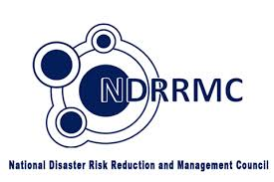

**National Disaster and Risk Reduction and Management Council (NDRRMC) hotlines**

(02) 911-1406, (02) 912-2665, (02) 912-5668, (02) 911-1873



**Bureau of Fire Protection (NCR)**117, (02) 729-5166, (02) 410-6319 (Regional Director, Information Desk)

**Philippine National Police (PNP) Hotline Patrol**117 or send TXT PNP to 2920

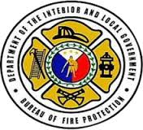



**Department of Transportation and Communications (DOTC) hotline**7890 or (02) 726-6255

**Metro Manila Development Authority (MMDA)**136, 882-0925 (flood control)  
Trunkline: (02) 882-4150-77 loc. 337 (rescue), 255 (Metrobase)  
Metrobase: 882-0860





**Department of Public Works and Highways (DPWH)**(02) 304-3713, (02) 304-3904



**Red Cross hotline**143, (02) 527-0000, (02) 527-8385 to 95



**Subic-Clark-Tarlac Expressway (SCTEX) hotlines**  
(0920) 96-SCTEX (72839) (traffic hotline) or (045) 459-0522

**North Luzon Expressway (NLEX) hotlines**  
(02) 3-5000 and (02) 580-8910



**Skyway System Hotline**  
(02) 776-7777, 0917-539-8762 (globe), 0999-888-0893 (smart), 0932-854-6980 (sun)



**South Luzon Expressway** **(SLEx) hotline**  
0917-6877539 (globe), (049) 508-7509, (02) 584-4389



**Philippine Atmospheric, Geophysical and Astronomical Services Administration**(**PAGASA) hotline**(02) 433-8526



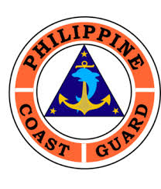

**Philippine Coast Guard**  
(02) 527-3877, (02) 527-8481, 0917-724-3682 (globe), 0917-PCG-DOTC (globe)



**PHIVOLCS**  
Trunkline: (02) 426-1468 to 79, local 124/125 (emergency);  
Text/call: 0905-313-4077 (globe)

**Manila Water Hotline**  
1627



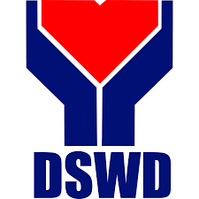

**DSWD**(632)931-81-01 to 07, local 426 (Disaster Response Unit); (02) 951-7119

Manila Traffic Hotline – 527-3087  
Cainta Traffic Hotline – 646-0044, (02) 248-1743 (hotline)  
Las Piñas Traffic – 874-5756, 874-3927, 874-5754, 874-5753  
Mandaluyong Hotline – 534-2993 (traffic); 533-2225 (Command Control Center)  
Taguig Traffic – 838-4301 loc. 7112  
Marikina STOC – 646-1651, (02) 646-1633 (traffic)  
Pasig Traffic – 643-0000 (Command Control Center); 643-1111  
Makati Public Safety Dept – 844-3146, 819-3270 to 71